QUEEN TRAPPER COMPETITION FORM

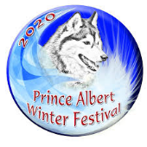
Name (please print):
Address:
City/Town & Province:
Postal Code:
Phone Number:
ENTRY FEE OF $70.00 MUST ACCOMPANY COMPLETED FORM

LIST OF EVENTS: (check the events that you’ll be participating in)

Saturday Sunday

[ ] Buckskin Parade/Jigging [ ] Buckskin Parade/Jigging (participation only)

[ ] Animal Calls [ ] Bird Calls

[ ] Pack Race ( ) Rope Winding

[ ] Log Toss [ ] Sled Pull

[ ] Trap Setting [ ] Canoe Pull

[ ] Swede Saw

[ ] Axe Throwing

[ ] Snowshoe Race [ ] Water Boil

TRAPPERS MUST BE 18 YEARS OF AGE OR OLDER:

AGREEMENT: I agree to be responsible for my conduct, abide by all rules and decisions of officials, which are final. I shall not hold the Prince Albert Winter Festival, any other sponsor or landowner liable for any injury to equipment
or myself.

Date: ________________________________ Signature: ______________________________________

